**Group D:RTI Settings Experiment, Georgia O’Keeffe Museum**

**Members**

Anthony Casaretto

Aaron Jauregui

April Mao

Kevin Neal

1. **Introduction and Background**
   1. **RTI Technology**
   2. **ISO Experiment**
2. **Procedure and Experiment Design**
   1. **Dome Setup**
   2. **Data Collection Process**
   3. **Data Processing Using MatLab**
3. **Findings and Analysis**
   1. **ISO Consistency**
      1. **Figure 1**
   2. **ISO Using ISO 100 as Base Case**
      1. **Figure 2**
   3. **Problems/Setbacks**
4. **Conclusion**
   1. **Summary of Findings**
   2. **Future Applications**
      1. **Other Potential Experiments**
5. **Acknowledgments**

**1. INTRODUCTION AND BACKGROUND**

**1.1. RTI Technology**

RTI (Reflectance Transformation Imaging) is a computational photographic method used to capture an object’s shape and color in an image while also allowing interactive relighting of the object from any direction. It also allows the user to enhance an object’s surface shape and color attributes in order to allow better analysis of the details/blemishes on an objects surface. An RTI image is composited from a set of digital photographs of an object, with each photo taken with the light projected from a different direction. The information from each of these photos is then gathered in order to form the single RTI image. The relighting of the image is made possible by the information gathered which creates a pseudo 3d representation of the object which allows the RTI image to calculate how light will reflect off the object.

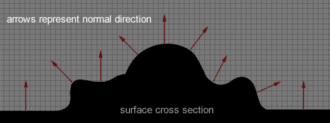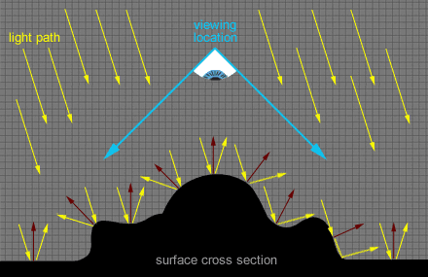

**1.2. ISO Experiment**

Our task was to determine whether or not changing the ISO during the image gathering process plays a significant role in the generation of the normal map. Since ISO 100 is the standard used when gathering RTI data, we used that as our control group. To start, we took five sets of photos at each ISO setting to calculate the average error between the generated normal maps within a single ISO. This gave us an idea of how consistent each ISO was for gathering the normal data. After that, we took the averaged values at each ISO and compared those values to the averaged values of the base ISO 100. All of this analysis was done on a pixel by pixel basis and averaged all together to get the final plots.

**Procedure and Experiment Design**

**2.1. Dome Setup**

To gather the data, we used the RTI dome. This is a dome equipped with 81 lights all set at different angles. The dome rests over the image and takes 81 pictures - one with each light - which can then be run through a provided script that will create an RTI file.

To setup the actual dome, the camera is secured in place on top and looks down at the image - in this case a small 8x8 oil painting - preventing outside light from getting in. The camera is then hooked up to the dome, so that it can automatically take the pictures.

**2.2. Data Collection Process**

We further hooked up the camera to a laptop via USB, and using an open source software we were able to change the ISO settings from the laptop. We collected 5 images for each of the 8 ISO settings - 100, 200, 400, 800, 1600, 3200, 6400, and 12800 - for a total of 40 RTI files. As we doubled the “film speed”(ISO) which generates more light, we had to double the shutter speed to compensate. This ensured that all pictures would take in an equal amount of light.

From these images, we were able to use the RTI-viewer software to take a snapshot of the normal maps. Unfortunately, the software would not allow us to change the settings while the camera was hooked up to the dome, so we had to carefully detach and reattach the cable to change the ISO and shutter speed of the camera.

**2.3. Data Processing Using MatLab**

Once we had the normal maps for all 40 of the images, we needed to analyze the data to see if there were any changes. To accomplish this, we needed to look at the data sets in two different ways.

The first way we analyzed the data was to compare each ISO set against itself. To do this, we took the first image in each set and compared it with the other 3 images of that same ISO[1]. The metric we used for these comparisons was the average change in normal angle per pixel. To get the normal angle, we looked at each pixel individually and took the dot product versus the other images to get 3 angle values. We averaged all of these values to obtain our final plot, which represents the average consistency for each ISO.

Next we looked at the ISOs when compared with ISO 100 as our baseline. To do this, we averaged the angle at each pixel using the 4 pictures from each ISO. This gave us a 2D matrix which held the average normal value for each pixel for each ISO. We then compared each of these matrices with the ISO 100 matrix and averaged the angle difference. This then gave us the average change in normal angle compared to ISO 100.

**Findings and Analysis**

**3.1. ISO Consistency**

**3.1.1. Figure 1**

When looking at the consistency of each ISO, our results were all over the place. In general, the error goes up, however we see a spike down at ISO 200, and a spike up at ISO 400. The amount of error is extremely low however, ranging from 0.1544**°** 0.3020**°.** 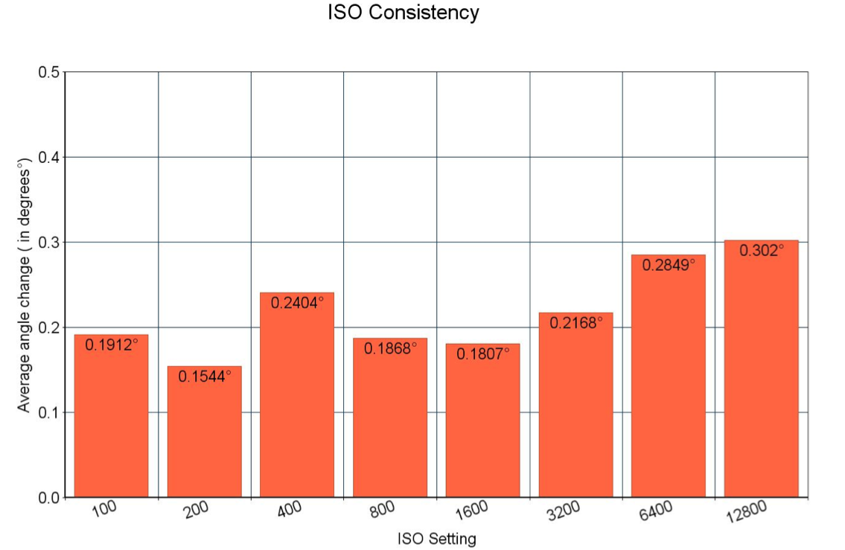

This seems to indicate that as far as consistency goes, changing the ISO doesn’t matter a whole lot. The spike at ISO 400 could have came from not being careful enough when we took out the cable connecting the dome to the camera, or some other outside factor.

**3.2. ISO Using ISO 100 as Base Case**

**3.2.1. Figure 2**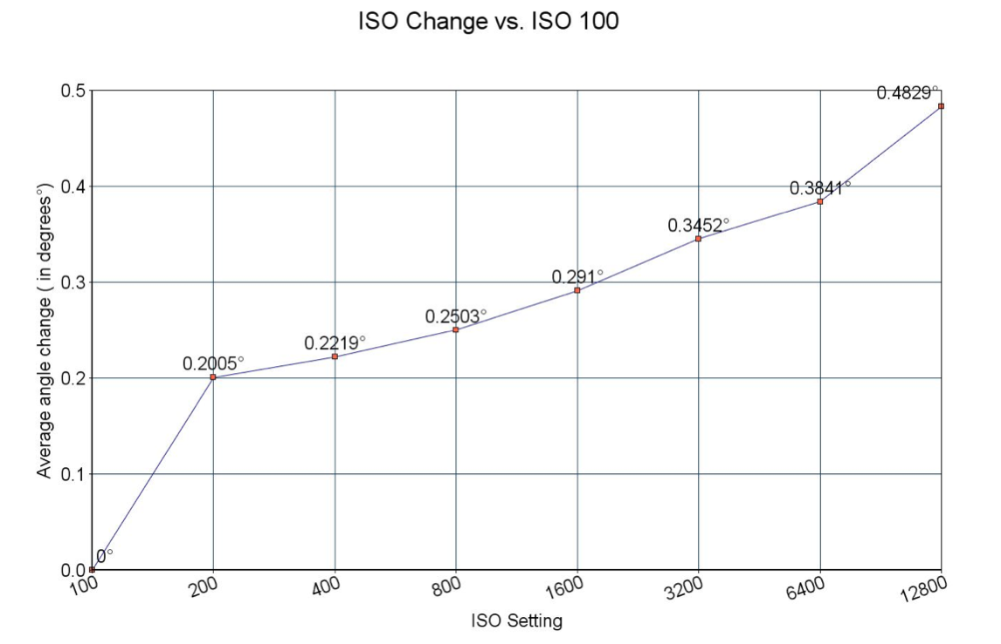

When comparing all of the ISOs against ISO 100, the results were more consistent. For all seven other ISOs, there is a steady increase in the average angle change per pixel.

This indicates that as ISO is increased, the normal maps do get more distorted. Again however, this change is very small, ranging from 0.2005**°**  to 0.4829**°.**

**3.3. Problems/Setbacks**

Upon collecting our first set of data, we only changed the ISO, as to keep all other variables controlled. We failed to account for the fact that this would make the images more blown out as we increased the ISO. We redid our image capturing process for each ISO and this time we accounted for the increase in light exposure by increasing the shutter speed to correspond correctly with each ISO setting. This allowed for a more appropriate set in which the amount of light being captured by the camera was constant, even if we changed multiple settings.

This was mostly difficult due to the time intensive process of collecting so many RTI images. To collect the 40 RTIs took about 4 hours, as we not only had to run the dome, but we had to transfer the photos to the proper folder to run the script and make the RTI file. We then had to load these into RTI viewer, change the view to the normal map, and export a snapshot of each as a PNG.

On top of this, in our original set we noticed that much of the noise was contained in the black felt background of the dome where our image was taken. This lead to much greater error when comparing the images, and in our second set we made sure to crop the images uniformly so they contained only the oil painting.

Another issue we found, after we had already finished our tests, was that we were taking images at a fairly low resolution (720 x 480) which meant much of the color data, per pixel, in our photos had been lost due to the fewer number of pixels. This could account for the extremely low calculated error between each ISO. To remedy this, we would have to recapture our data sets, as raw images, in order to increase the accuracy of our comparisons..

**Conclusion**

**4.1. Summary of Findings**

In this experiment, we found that although changing the ISO does make a difference, it tends to be a very minor difference; both with the consistency of a single ISO and when compared to the ISO of best quality (ISO 100). Our findings only apply to lower resolution images however, and the difference between higher resolution images may be much higher.

Clearly more tests are needed to confirm this for certain, but from the data we’ve collected and analyzed, it appears ISO has little to do with obtaining accurate and consistent surface normals at the settings used in this experiment.

**4.2. Future Applications**

**4.2.1. Other Potential Experiments/ Needed Tools for Better Workflow**

Our code could easily be modified to look at different camera settings and compare how the surface normals are affected. The most difficult part of this experiment was collecting enough good data to analyze. On the other hand, the most time consuming parts were making sure that all the camera settings were in order, transferring the files between programs, and running the scripts. Streamlining this process would go a long way in testing the limits of the RTI dome technology, and of the RTI builder in general.

Collecting the data was very repetitive. Namely, we had push “start” on the dome to collect the 81 pictures multiple times, move them to a folder, run a script, and move the resulting RTI file and rename it to our liking. It’s foreseeable that this could all be automated, and the start button could be pushed just once to obtain the entire set of images, in which ever format was desired: jpg or png, normal map or specular, etc.

**Acknowledgments**

Thanks to Jing Liu for providing scripts to create the RTI files.

Thanks to Bipeng Zhang for help debugging with MatLab.

Thanks to Cultural Heritage Imaging for the RTI viewer software.

Thanks to Breeze Systems for the open source tool DSLR remote pro.

Thanks to James Davis for being helpful in guiding us during the process of this project.

1. The first picture of the ISO 100 set got spoiled - it had significant change in color, visible to the human eye, while no other photo was easily distinguishable from any other. To correct this, we made image 2 our comparison image, and compared it to images 3, 4, and 5. This made our sample size smaller overall, but evened things out among all ISOs.